 Guidance on Traffic and Pedestrian Barriers
Metal crowd control barriers are increasingly being used in situations where plastic Traffic and Pedestrian Barriers are the safer solution. Their purpose at works on the highway is to guide vehicles and pedestrians safely and separately around hazards on or near the road without the barriers themselves being an intrinsic hazard. The advice from the Department for Transport is therefore that barriers exposed to vehicular traffic should appear substantial but not be substantial and that lightweight frangible systems should be used except where pedestrians are at special risk.
This information sheet is intended to help users understand how works on the highway should be protected by barriers. There is often confusion over the specification and use of Pedestrian and Traffic Barriers as the mandatory requirements and guidance are spread across four different documents listed below. Requirements for Traffic Barriers and for Pedestrian Barriers are different but to avoid double stocking and the risk of the wrong barrier being deployed most barriers on the market are dual purpose traffic/pedestrian barriers. For similar reasons barriers are generally also double sided. The generic illustration below shows a dual purpose barrier that complies with all four documents and the dimensions/notes are colour coded to indicate the document from which they are taken.
The Traffic Sign Regulations and General Directions 2002 (TSRGD)
Compliance with TSRGD is mandatory for all signs/devices on the public highway
A Code of Practice for Safety at Road Works and Street Works (The Red Book)
Effectively mandatory under the New Roads and Street Works Act for the public utilities and best practice for others.
Chapter 8 (2009) of the The Traffic Signs Manual
Not mandatory but provides more detailed DfT guidance than the Red Book and represents best practice.
BS 8442 (requires reflectivity to comply with BS EN 12899-1 or BS 8408)
The British Standard setting out recommended minimum performance levels for barriers which identifies three wind speed/site categories and provides a calculation model to determine the ballasting required in each. REMA barrier manufacturers provide installation and ballasting advice to their customers to enable them to install stable barrier systems in each wind speed category.
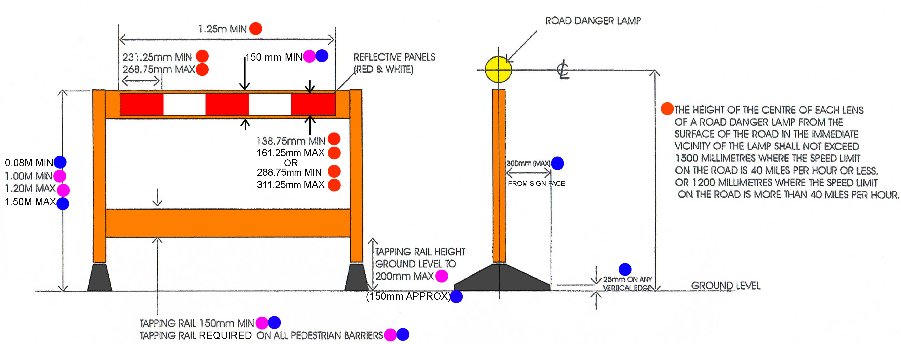
The red/white panels must be reflectorised to BS 873 Part 6 (Class 1 or 2) or the equivalent standard of an EEA state.
Note: BS 873 has been withdrawn. This requirement will be met by reflective materials that meet the R_{A} minimums in BS EN 12899-1 class RA1 (equivalent to Class 2 above) or RA2 (equivalent to Class 1 above).
Wooden or tubular steel poles shall not be used as horizontal barriers as they constitute a serious hazard should a vehicle collide with them.
REMA members supplying safe and compliant dual-purpose barriers are:
MELBA SWINTEX JSP OXFORD PLASTIC SYSTEMS
For contact details visit the ‘Members’ page of the REMA website at www.rema.org.uk.
Revised March 2011

